ASC Tutorial Center Database
Group Seven
Cadence Liles, Leslie Gonzalez, Sarjan Thakuri, Darshan Dahal, Hamzah Kourdieh

Table of Contents
Introduction 3
User requirements 3
Entity relationship diagram 4
Relational schemas 5
SQL Implementation 7
Schema validation tests 7
SQL Functional test 7
Database application 10
Database application tests 11
Functional testing 11
Security testing 14
Future work 17
Conclusion 17
Work distribution 17

Introduction
The ASC Tutorial Center requires a data management system to organize the persons apart of the center including the managers, students, and the tutors as well as organizing the sessions, subjects offered, tutors’ expertise, and languages utilized. Previously, the center relied on spreadsheets and manual scheduling, which often resulted in duplicated data and misplaced information, leading to it being difficult to track session information for tutors and students’ attendance.

The goal of this project is to design and implement a relational MySQL database that supports the core operations of the tutoring center. This database provides a structured, consistent, and scalable way to:

- Manage people (students, tutors, and managers)
- Track tutoring sessions and attendance
- Store subjects and tutor expertise
- Maintain language fluency and availability
- Ensure referential and data integrity across all tables

User requirements
There are three types of users in this system. Each type needs specific functionalities that drove the database design.

Mangers:
Mangers oversee tutors and maintain system data. They require the ability to:
- Add, modify or remove tutor records,
- Assign tutors to subjects,
- Review session schedules,
- View student attendance,
- Update subjects and center offerings,
These requirements make the following tables necessary: Mangers, Tutors, Expertise, SubjectsOffered, and Session.

Tutors:
Tutors interact with the system to manager their workload and track performance. They need to be able to:
- Indicate the subjects they are qualified to teach
- Indicate which languages they speak fluently
- View sessions assigned to them
- Track Attendance for students attending their sessions
This resulted in the need for Fluency, Expertise, and Session tables.

Students:
Students use the system to do the following:
- Register for tutoring sessions
- View available subjects
- State their preferred language
- Track attendance history
These requirements create the need for Student, Attend, and Session tables.

Entity relationship diagram
Description:
- Person
  - Stores the core identity of anyone in the system. This relation is needed because students, tutors, and mangers all share common attributes.
- Student
  - Extends Person. Represents any student who attends tutoring sessions.
- Tutor
  - Extends Student. Tutors must be students in this system meaning that the tutors are students themselves. This relation is needed to track teaching roles, hiring dates, assignments, and managerial relationships.
- Manger
  - Extends Person. Managers supervise tutors, generate reports, and oversee operations
- SubjectsOffered
  - Stores the subjects taught by tutors and offered in sessions.
- Expertise
  - Links tutors to the subjects they can teach with their years of experience. Relation is needed for assigning qualified tutors.
- Available Language
  - List the languages the tutoring center can cater too. There is only one language per session, but many sessions can have the same one language.
- Fluency
  - Connects tutors to languages they can teach in.
- Session
  - Represents scheduled tutoring sessions including date, time subject, tutor, location, and language.
- Attend
  - Logs student registration and attendance history.
Business Assumptions:
- Tutors must be students in the system
- Every session is taught by only one tutor at a time
- A tutor can teach using multiple languages and teach multiple subjects
- A student may register for multiple sessions
- More than one student can attend the same session.
- Each subject must exist before assigning tutor expertise.
- Person must exist in the system before being assigned as either a manager, student, or student and tutor.

Relational schemas
Person( SystemID: int, FirstName: string, LastName: string, Email: string, PhoneNum: int, UserName: string, Password: string)

Managers(DateHired: yyyy/mm/dd, SystemID)
SystemID is FK referencing Person.SystemID

Student( PreferredLanguage: string, SystemID) )
SystemID is FK referencing Person.SystemID

Tutors(DateHired: yyyy/mm/dd, ManagedBy: int, SystemID)
ManagedBy is FK referencing Manager.SystemID,
SystemID is FK referencing Student.SystemID.

SubjectsOffered(SubjectID: int, SubjectName: string, TutorCount: int (derived))
TutorCount is derived attribute calculated by counting rows in the expertise table

Expertise( YearsOfExperience: int, SystemID, SubjectID)
SystemID is FK referencing Tutor.SystemID,
SubjectID is FK referencing SubjectsOffered.SubjectID

Session(SessionID: int, Date: yyyy/mm/dd, SessionTime: time, Location: string, StudLim: int, SubjectID, SystemID, LanguageID)
SubjectID is FK referencing SubjectsOffered.SubjectID,
SystemID is FK referencing Tutor.SystemID,
LanguageID is FK referencing AvailableLanguage.LanguageID

Attend ( DateReg: yyyy/mm/dd, Status: string, SystemID, SessionID)
SessionID is FK referencing Session.SessionID,
SystemID is FK Student.SystemID

AvailableLanguage ( LanguageID: int, Language: string)

Fluency( LanguageID, SystemID, Fluent: string)
LanguageID is FK referencing AvailableLanguage.LanguageID,
SystemID is FK referencing Tutor.SystemID

Special Case Mapping:
- Tutor inherits from Student implemented using shared primary key
- Fluency ses composite PK for many-to-many relationship
- Session references Tutor and Language independently
- Expertise uses composite PK to avoid duplicate mappings

SQL Implementation

Schema validation tests

Summery:
- Table relations match the ERD
  - Only slight issues with the Persons table not connecting to the Student and Manager table despite all code being correct but was able to manually connect them.
- FK constraints match design
- Composite keys implemented correctly
- No mismatched data types

SQL Functional test
Here are some cases that can occur that the database can satisfy.

Test Case 1: If a manager or student wants to see all tutors who can teach in Spanish
Query:
Select p.FirstName, p.LastName
From Tutor as t
Join Fluency as f
on t.SystemID = f.SystemID
Join AvailableLanguage as l
on f.languageID = l.languageID
Join person as p
on t.systemID = p.systemID
Where l.language = 'Spanish';

Which would produce:
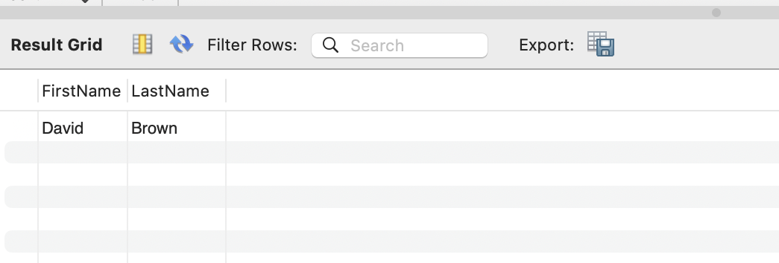

Test Case 2: A manger or tutor wants to check how many students are registered to attend a certain session
Query:
Select p.FirstName, p.LastName
From Attend as a
Join Person as p
on a.SystemID = p.SystemID
Where a.SessionID = 1;

Which produces:

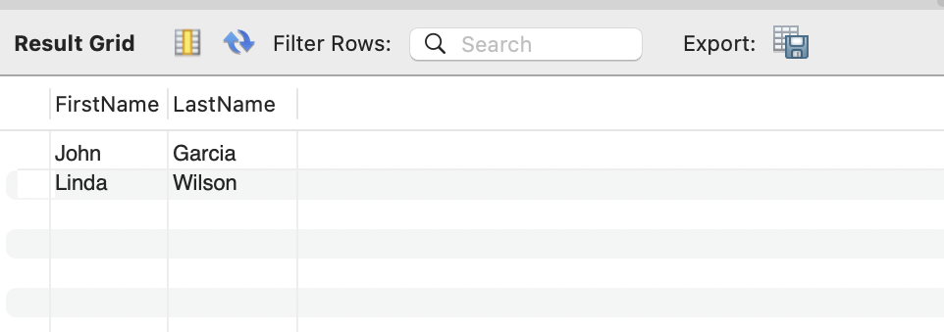

Test Case 3: A manager or a tutor wishes to see how many
sessions the tutor has scheduled
query:
Select SessionDate, SessionTime, Location
From Session
Where SystemID = 3;
Which would show:
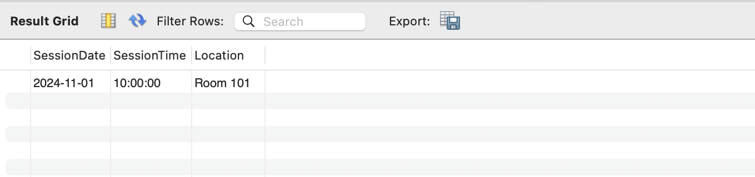

Test Case 4: A student or manager wants to know how many tutors can teach a certain subject, like math
Query:
Select p.FirstName, p.LastName, e.YearsOfExperience
From Expertise as e
Join Person as p on e.SystemID = p.SystemID
Where e.SubjectID = 1;

Which is
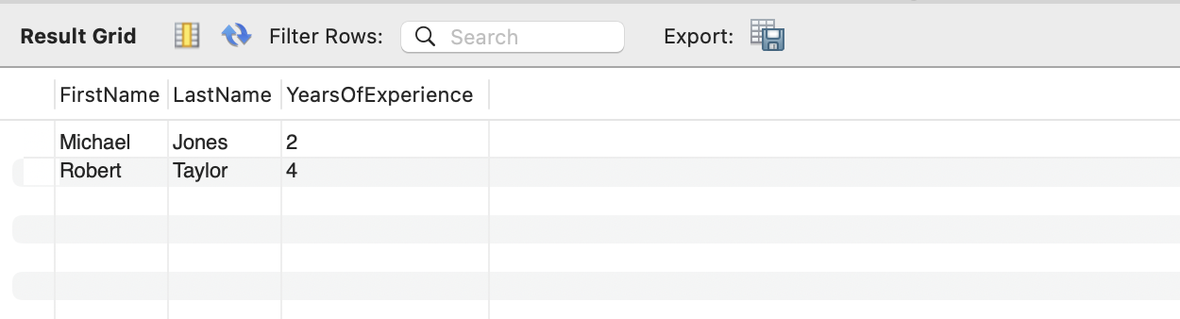

All the tests align with the business requirements because they create an efficient detailing of the information. Allowing for the different parties to manage, track, and gain information to suit their needs and the needs of the ASC Tutorial Center. And most importantly, ensure referential and data integrity across all tables to ensure there are minimal mishaps and mix-up which allows for the center to run smoothly and focus on what is important, helping tutor students.

Database application
The technologies used for the project are MySQL, IntelliJ, and jFrame
Here is a manager’s view seeing all sessions:
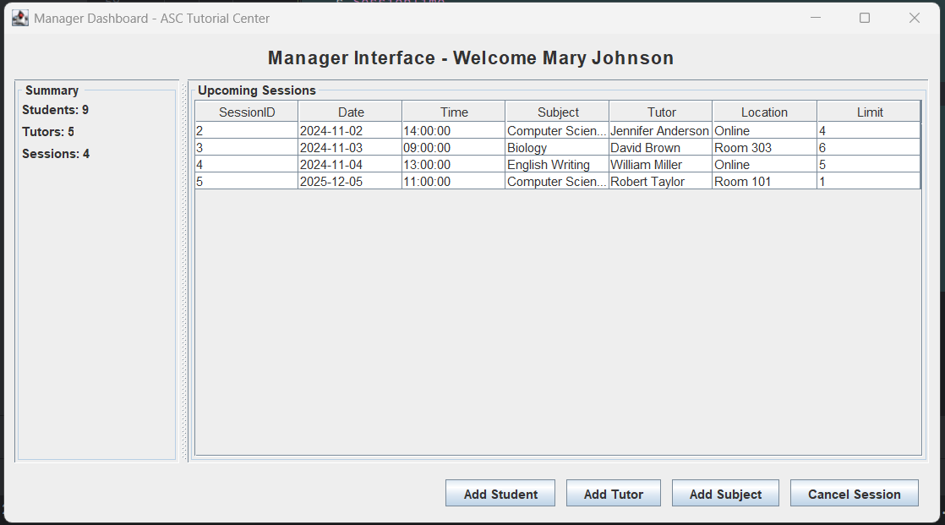

Database application tests

Functional testing
End-to-End Scenarios:
Adding a new record: For example, a student or tutor creating a new session
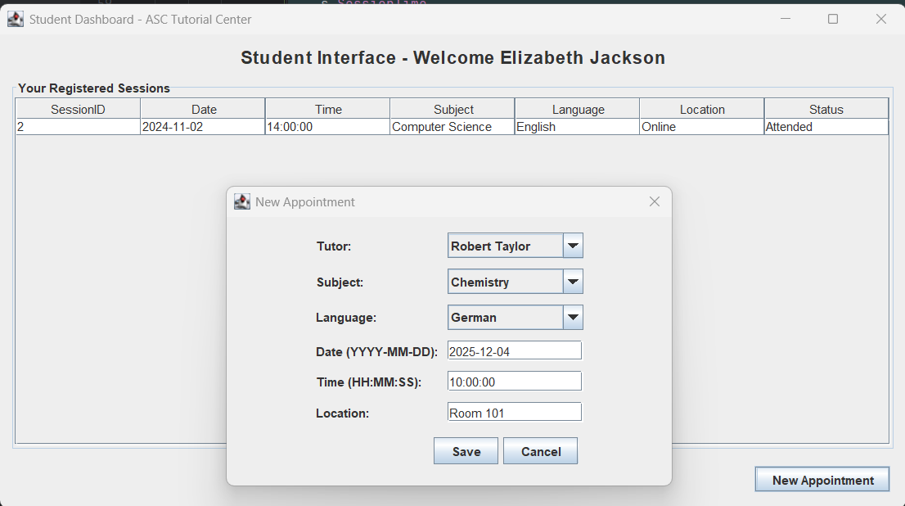
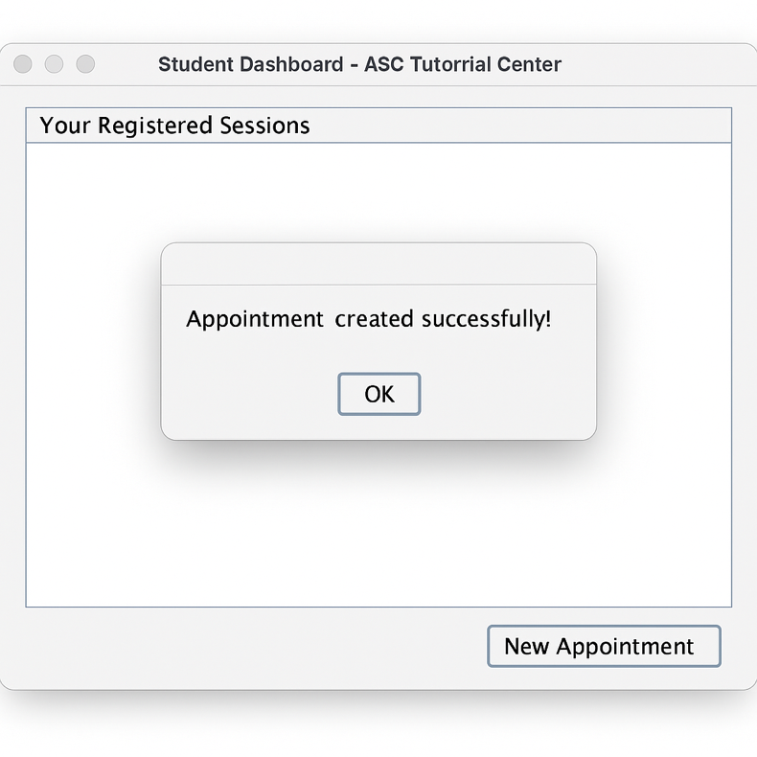

Deleting a record: For example, a manager deleting a session
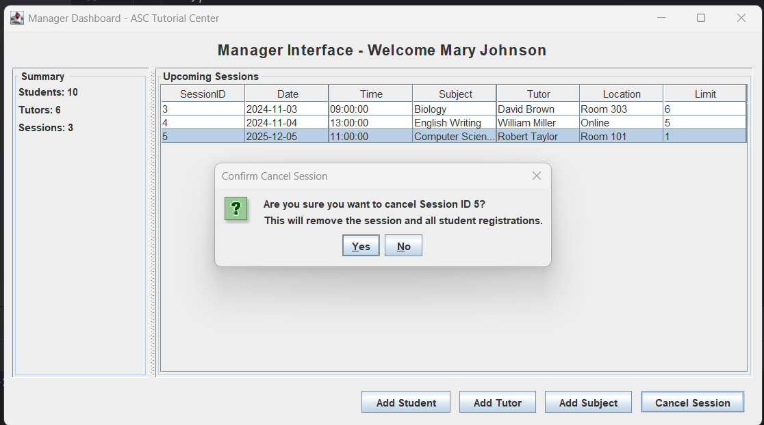

Data Consistency:
To ensure that the system maintains accurate and reliable information, data consistency tests were performed using both the front-end GUI and the underlying MySQL database. For each operation, such as adding a tutor, registering a student for a session, or updating subject, the resulting data was crosses-checked directly in the database to confirm that all changes were stored correctly. These test verified that no data was lost, duplicated, or corrupted during insert, update or delete operations. Additionally, relationship constraints were reviewed to ensure that all foreign key dependencies were respected when data was modified.

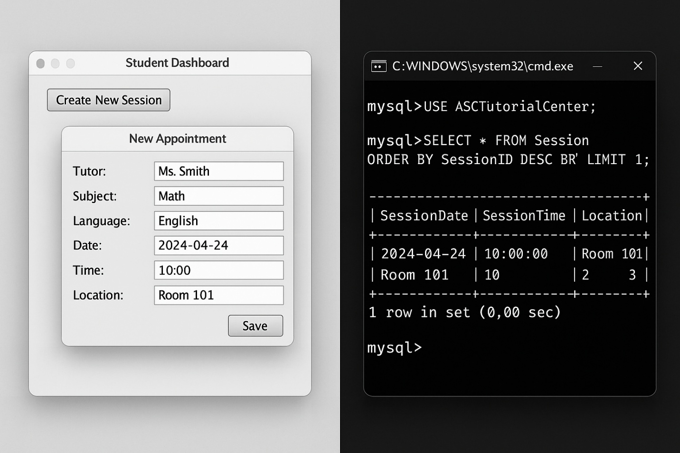

Error Handling:
Error-handling tests were conducted to confirm that the system responds appropriately to invalid inputs, failed operations, and database connectivity issues. The goal was to ensure that the users receive clear, helpful feedback rather than technical error messages. Examples include entering duplicate primary keys, missing information, or imputing something in the wrong format, like the date. In each case, the system’s error messages were evaluated based on clarity, accuracy, and user-friendliness. The application successfully prevented invalid data from being stores and provided guidance to users on how to correct their mistakes.

Best Practices:
Test cases were developed based on realistic scenarios derived from user requirements, ensuring that each test reflected actual workflows within the ASC Tutorial Center. These scenarios included actions such as a student registering for a session, or a manager deleting a session. By grounding test cases from real world expertise, the testing process more accurately validated whether the system behaves as expected and supports typical user interactions. This approach helps identify potential weak points in usability and data flow.

Security testing
Tests:
Authentication and Authorization:
Authentication test confirmed that users must log in before accessing the system. Each role, manager, student, or tutor, was evaluated to ensure it only has access to features permitted by the role-based design. Managers can modify tutor and subject data, students can only interact with their own session information and register for sessions. This test verified that unauthorized users cannot view or modify restricted data.

SQL Injection:
SQL injection tests were performed by entering malicious SQL strings into input fields to determine whether they system could be manipulated. Because the system does not accept raw SQL from user input and uses controlled string validation and predefined quires, injection attempts were not executed. In a dull system implementation, the use of prepared statements would be required to guarantee injection protection, and test cases were designed with this expiation in mind.

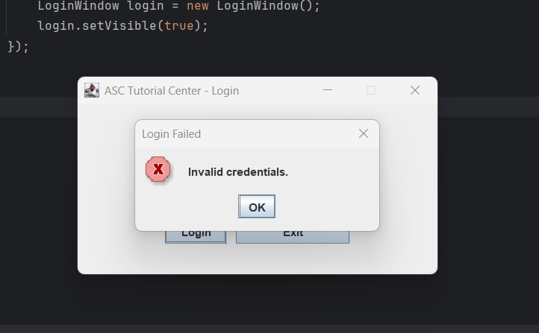

Password Handling and Security Concerns:
The current implementation uses simple string-based validation for passwords rather than hashing or encryption. While this is okay for a prototype system, it lacks the security needed for real world applications. Proper deployment would require hashing passwords using algorithms such as MD5, ensuring that passwords cannot be retrieved if the database is accessed by unauthorized parties. This limitation was noted during testing, and we are aware it is an important are for future improvement.

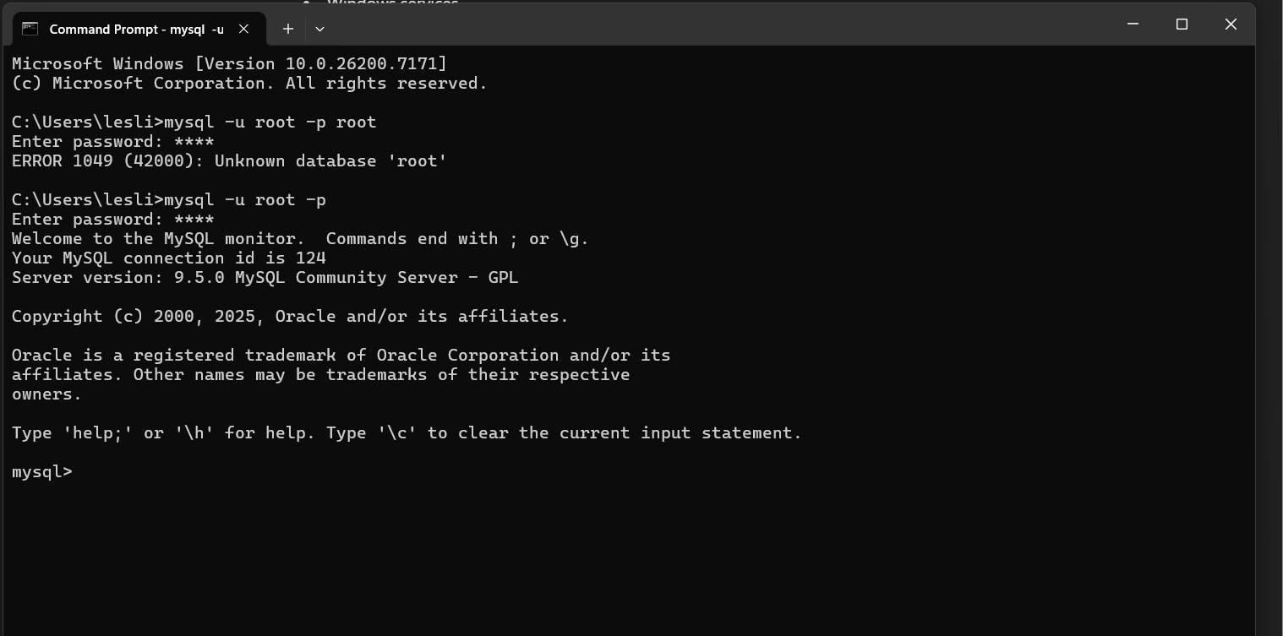
Connectivity, connection query and database authentication using database logins

Future work
Future Improvements may include several enhancements to increase the efficiency and effectiveness of the system. The first one being automatic session reminders to help make sure tutors are where they need to be on time as well as improve attendance rates of the students. This feature would help both tutors and students stay organized and reduce missed sessions
Another Enhancement could be to develop a full scheduling system to detect tutor conflicts and to ensure that tutors are not over scheduled. This system would also ensure that every session has a qualified tutor, improving overall session coverage and efficiency.
A third major improvement would be to add an extra level of security. We would add hashing into the code. This way we could better keep the data of our users secure. As of now there is no overly sensitive information, but it is still an import thing to do to better serve the center.
The last improvement would be offering the option to include the topics within the subject for sessions. While this would require significant prep and possible corporation from professors at the school to upload their topics list, it would allow tutors to know exactly which topic(s) the student is requesting help on and can refresh their own knowledge and possibly prepare a method of instruction for the session all prior to meeting with the student.

Conclusion
In this project, we have designed and implemented a complete relational database for the ASC Tutorial Center. We translated business requirements int an ERD, bult relation schemas, implemented them in My SQL, and tested functionality with real sample data.
We have learned:
- Convert real-world processes into database structures
- Resolve foreign key and relationship constraints
- Design inheritance and many-to-many relationships
- Use composite keys properly
- Write SQL to test business logic
- Debug schema errors and refine design decisions.
- Created an application UI

Work distribution
Cadence Liles Designed ERD, created schemas from ERD, coded MySQL database, assisted in putting together final report and co-created the presentation
Leslie Gonzalez-Cisneros co-created the presentation focusing on design and development. She also assisted on the project report and application testing with Darshan
Darshan Dahal worked on application coding based on the schema, UI design, testing IntelJ. He also assisted with the project report and the presentation.
Sajan Thakuri and Hamzah Kourdieh worked on professor’s feedback on schema.

